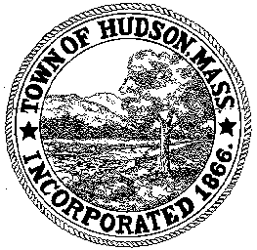

CONSERVATION COMMISSION
78 Main Street, Hudson, MA 01749
(978) 568-2020

Paul Byrne, Chairman W. Minot Wood, Vice Chairman David Esteves, Member

Terrence Joyce, Member Leif Longtine, Member Joseph Rodrigues, Member Al Tashian, Member

Agenda
December 17, 2009 7:00 P.M.

- Preliminaries
  - Open Meeting
  - Roll Call
1.3 Additions or Deletions to the agenda

2.0 Hearings and Appointments
2.1 Memorandum from Thomas Thorburn, Electrical Inspector
Re: 7 Freeman Circle
2.2 Enforcement Order - Continued
7 Freeman Circle

3.0 General Business
3.1 Questions and Comments from the Public

4.0 Adjournment

Next Meeting January 7, 2010

